Practical No.:
Aim :WAP in Python to Demonstrate Multiple Inheritance
Performedby :Ansh M. Sugandhi
Class :B.Sc.III SemVI (COSE)
Date :11/03/2025 class Poissonier:
definit(self, poissonier_role):

self.poissonier_role = poissonier_role defdisplay_poissonier_chef_info(self):
print(f"Chefismainlyinvolvedinpreparing{self.poissonier_role}") class Entremetier:
def init(self, entremetier_role): self.entremetier_role = entremetier_role defdisplay_entremetier_chef_info(self):
print(f"Chefismainlyinvolvedinpreparing{self.entremetier_role}") class Cook(Poissonier, Entremetier):
definit(self,poissonier_role,entremetier_role):

Poissonier.init(self, poissonier_role) Entremetier.init(self, entremetier_role)def invoke_base_class_methods(self): Poissonier.display_poissonier_chef_info(self)
Entremetier.display_entremetier_chef_info(self) def main():
print(f"IsCookaderivedclassofPoissonierBaseClass?{issubclass(Cook, (Entremetier, Poissonier))}")
chef=Cook("SeaFood","Vegetables") chef.invoke_base_class_methods()
if name =="main":

main()

Output:

IsCookaderivedclassofPoissonierBaseClass?True Chef is mainly involved in preparing SeaFood
Chefismainlyinvolvedinpreparing Vegetables

Practical No.:

Aim :WAP to demonstrate Polymorphism in Python
Performedby :Ansh M. Sugandhi
Class :B.Sc.III SemVI (COSE)
Date : 08/04/2025

class Vehicle:
definit(self, model):
self.model=model
defvehicle_model(self):
print(f"VehicleModelnameis{self.model}") class Bike(Vehicle):
defvehicle_model(self):
print(f"VehicleModelnameis{self.model}") class Car(Vehicle):
defvehicle_model(self):
print(f"VehicleModelnameis{self.model}") class Aeroplane:
pass
defvehicle_info(vehicle_obj): vehicle_obj.vehicle_model() def main():
ducati = Bike("Ducati-Scrambler") beetle=Car("Volkswagon-Beetle") boeing = Aeroplane()
foreach_objin[ducati,beetle,boeing]: try:
vehicle_info(each_obj) except AttributeError:
print("Expectedmethodnotpresentintheobject") if name == "main":
main()

Output :
Vehicle Model name is Ducati-Scrambler VehicleModelnameisVolkswagon-Beetle Expected method not present in the object

Practical No:

Aim :-WAP to read the content so file in reverse order.
PerformedBy :-Ansh M. Sugandhi
Class :-B.Sc.III SemVI (COSE)
Date :- 08/04/2025

Step1:OpenPycharmandopenyourproject.Thenrightclickonprojectwhereyouwant the
NewDirectory.
Step2:Fromtherightclickcontextmenu,selectNewgoto directory.
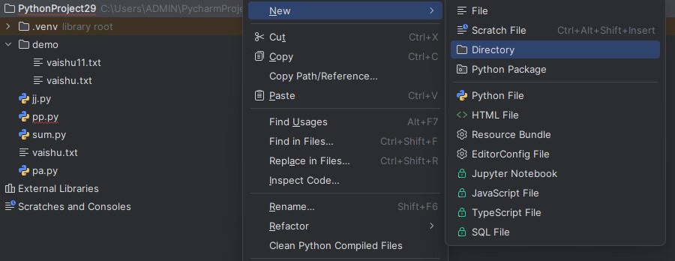
Step3:Enterthedirectoryname
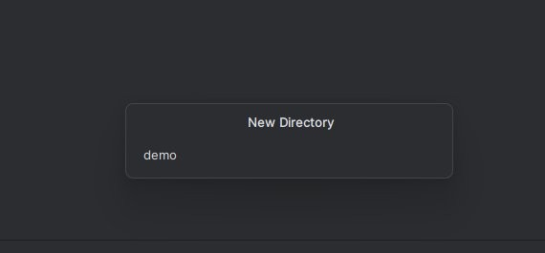
Step4:Createavaishu11fileindemodirectorywith.txtextension.Thecontentof vaishu11.txt is given below:
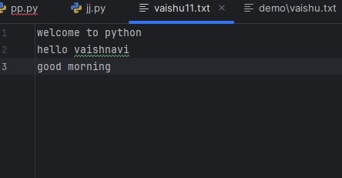

Step5:Forreversingthecontentofvaishu11.txtfile,codeisgiven below:

defread_file_reverse(filename): try:
#Openthefileandreadalllines
withopen(filename,'r',encoding='utf-8')asfile: lines = file.readlines()

# Print lines in reverse orderprint("\nFilecontentinreverseorder:\n") for line in reversed(lines):
print(line.strip())

except FileNotFoundError:
print(f"Error:Thefile'{filename}'wasnotfound.") except Exception as e:
print(f"Anerroroccurred:{e}")

#Specifythefilename
filename="demo/vaishu11.txt"#Ensurethisfileexistsinthesamedirectory

# Call the function read_file_reverse(filename)

Step6:Outputoffilecontentinreverse order:

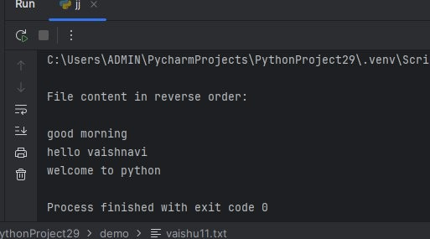

Practical No:
Aim :-WAP in Python to demonstrate working with dictionaries.
Performedby :-Ansh M. Sugandhi
Class :-B.Sc.III SemVI (COSE)
Date :- 18/02/2025

#Creating a dictionary
student={"name":"Savi","age":20,"course":"ComputerScience","grade":"[75,85,90]"}

# Display the dictionary print("OriginalDictionary:",student)

# Accessing elements using keys print("StudentName:",student["name"]) print("Student Age :",student["age"])

#Modifyingavalue student["age"]=21
print("UpdatedAge:",student["age"])

#Addinganewkey-valuepair student["city"]="Nagpur"
print("Dictionaryafteraddingcity:",student)

# Removing a key-value pair removed_value = student.pop("course") print("Removed'course':",removed_value) print("Dictionary after removal :",student)

# Getting all keys and values print("Keys :",list(student.keys())) print("Values:",list(student.values()))

#Checkingifakey exists
print("Is'grades'indictionary?","grade"instudent)

#Iteratingthroughdictionary print("Dictionary Items :")
forkey,valueinstudent.items(): print(key,":",value)

#Usingget()to accessavalue safely
print("StudentGrades:",student.get("grade","Nogradesfound"))

#Clearingthedictionary student.clear()
print("Dictionaryafterclearing:",student)

Output :
#Creating a dictionary
OriginalDictionary:{'name':'Savi','age':20,'course':'ComputerScience','grade': '[75,85,90]'}

#Displaythe dictionary
#Accessingelementsusingkeys Student Name :Savi
StudentAge:20
UpdatedAge:21

# Modifying a value
Dictionaryafteraddingcity:{'name':'Savi','age':21,'course':'ComputerScience', 'grade': '[75,85,90]', 'city': 'Nagpur'}

# Removing a key-value pair Removed'course':ComputerScience
Dictionaryafterremoval:{'name':'Savi','age':21,'grade':'[75,85,90]','city': 'Nagpur'}

# Getting all keys and values Keys:['name','age','grade','city']
Values:['Savi',21,'[75,85,90]','Nagpur']

#Checkingifakey exists
Is'grades'indictionary?True

#Iteratingthroughdictionary Dictionary Items :
name:Savi age : 21
grade:[75,85,90] city : Nagpur

#Usingget()toaccessavaluesafely Student Grades : [75,85,90]

# Clearing the dictionary Dictionaryafterclearing:{}

Practical No:
Aim :-WAP Program to demonstrate the class and object.
PerformedBy :-Ansh M. Sugandhi
Class :-B.Sc.III SemVI (COSE)
Date :- 25/03/2025

importmath#Importmathmoduleforπ(pi) # Define a class
classCircle:
def init(self, radius): self.radius=radius#Attribute

defarea(self):
returnmath.pi*self.radius*self.radius#Formulaforareaof circle

#Createan object
c=Circle(5)#Circlewithradius5

#Printthearea
print("Areaofcircle:",c.area())

Output :
Areaofcircle:78.53981633974483

Practical No:
Aim :-WAPProgramtodemonstrateconstructormethod.
PerformedBy :-Ansh M. Sugandhi
Class :-B.Sc.III SemVI (COSE)
Date :- 25/03/2025

class Triangle:
definit(self,b,h):#Constructor(corrected) self.base = b
self.height=h

defarea(self):
return0.5*self.base*self.height

#Example usage
t=Triangle(10,5)#Constructoriscalledhere print("Area of Triangle:", t.area())

Output :
AreaofTriangle:25.0

Practical No.:

Aim :WAPinpythontoCalculateandAddtheSurfaceAreaofTwoCubes. Use Nested Functions
Performedby: Ansh M. Sugandhi
Class :B.Sc.III SemVI (COSE)
Date : 11/03/2025

defadd_cubes(a,b):

defcube_surface_area(x):

return6 * pow(x, 2)

returncube_surface_area(a)+cube_surface_area(b) def main():
result=add_cubes(2,3)

print(f"ThesurfaceareaafteraddingtwoCubesis{result}") if name == "main":
main()

Output:

ThesurfaceareaafteraddingtwoCubesis78

Practical No.:

Aim :WAPinpythontoDemonstratetheUseofDefault Parameters
Performedby : Ansh M. Sugandhi
Class :B.Sc.III SemVI (COSE)
Date : 11/03/2025

defwork_area(prompt,domain="DataAnalytics"): print(f"{prompt} {domain}")
defmain():

work_area("Samworksin")

work_area("Alicehasinterestin","InternetofThings") if name == "main":
main()

Output:

SamworksinDataAnalytics

AlicehasinterestinInternetof Things

Practical No.:

Aim :WAPinpythontoDemonstratetheReturnofMultipleValuesfroma Function Definition.
Performedby : Ansh M. Sugandhi
Class :B.Sc.III SemVI (COSE)
Date : 11/03/2025

defworld_war():

alliance_world_war=input("WhichalliancewonWorldWar2?") world_war_end_year = input("When did World War 2 end?") return alliance_world_war, world_war_end_year
defmain():

alliance,war_end_year=world_war()

print(f"Thewarwaswonby{alliance}andthewarendedin{war_end_year}") if name == "main":
main()

Output:

WhichalliancewonWorldWar2?Allies When did World War 2 end?1945
ThewarwaswonbyAlliesandthewarendedin1945

Practical No.

Aim :WAPinpythontoIllustrateMultipleParametersininit() Method.
Performedby :Ansh M. Sugandhi
Class :B.ScIIISEM-VI (COSE)
Date :28/03/2025

class Mobile:
definit(self, name):
self.mobile_name=name def receive_message(self):
print(f"Receivemessageusing{self.mobile_name}Mobile") def send_message(self):
print(f"Sendmessageusing{self.mobile_name}Mobile") def main():
nokia=Mobile("Nokia") nokia.receive_message() nokia.send_message()
ifname=="main": main()

Output:
ReceivemessageusingNokiaMobile Send message using Nokia Mobile

Practical No.
Aim :WAPinpythontoIllustratetheCreationofMultipleObjectsfora Class.
Performedby :Ansh M. Sugandhi
Class :B.ScIIISEM-VI (COSE)
Date : 28/03/2025

class Birds:
definit(self,bird_name): self.bird_name = bird_name def flying_birds(self):
print(f"{self.bird_name}fliesaboveclouds") def non_flying_birds(self):
print(f"{self.bird_name}isthenationalbirdofAustralia") def main():
vulture=Birds("GriffonVulture") crane = Birds("Common Crane") emu = Birds("Emu") vulture.flying_birds() crane.flying_birds() emu.non_flying_birds()
if name =="main": main()

Output:
Griffon Vulture flies above clouds Common Crane flies above clouds EmuisthenationalbirdofAustralia

Practical No.

Aim :WAP in python to Demonstrate Passingof an Objectasan Argument to a
Function call.
Performedby :Ansh M. Sugandhi
Class :B.ScIIISem-VI (COSE)
Date : 28/03/2025

classTrack:
definit(self, song, artist):
self.song = song self.artist=artist
defprint_track_info(vocalist):
print(f"Song is '{vocalist.song}'") print(f"Artistis'{vocalist.artist}'")
singer=Track("TheFirstTimeEverISawYourFace","RobertaFlack") print_track_info(singer)

Output:
Songis'TheFirstTimeEverISawYourFace' Artist is 'Roberta Flack'

Pratical No.

Aim :Writea python program demonstrate the list operations:

1)Createandprintalist | 2)Accesingelementbyindex | 3)Modify an element
4)Insertanelementataspecificindex the list | 5)POPan element | 6)Findthelengthof
7)Sortthelist | 8)Reversealist
PerformedBy:Ansh M. Sugandhi
Class :B.sc-IIISEM-III[COSE]
Mango : 5/04/2025

#Demonstratefollowinglistoperations # 1) Create and print a list
fruits=["apple","banana","cherry","mango","fig"] print("Original List:", fruits)
# 2) Accessing element by index print("Elementatindex2:",fruits[2])
#3)Insertanelementataspecificindex fruits.insert(1, "blueberry")
print("Listafterinserting'blueberry'atindex1:",fruits) # 4) Find the length of the list
length= len(fruits)
print("Lengthofthelist:",length) # 5) Reverse a list
fruits.reverse() print("Reversedlist:",fruits) # 6) Modify an element fruits[2] = "grape"
print("Listaftermodifyingindex2to'grape':",fruits) # 7) Pop an element
popped_element=fruits.pop(3)
print(f"Elementpoppedfromindex3:{popped_element}") print("List after popping an element:", fruits)
#8)Sort the list Fruits.sort() Print(“Sortedlist”:fruits)

Output :
OriginalList:['apple','banana','cherry','mango','fig'] Element at index 2: cherry
Listafterinserting'blueberry'atindex1:['apple','blueberry','banana','cherry','mango','fig'] Length of the list: 6
Reversedlist:['fig','mango','cherry','banana','blueberry', 'apple']
Listaftermodifyingindex2to'grape':['fig','mango','grape','banana','blueberry','apple'] Element popped from index 3: banana
Listafterpoppinganelement:['fig','mango','grape','blueberry','apple'] Sorted list: ['apple', 'blueberry', 'mango', 'fig', 'grape']

Practical no.
Aim :-WAP in python to check if a substring is present in a given string
Performedby:-Ansh M. Sugandhi
Class :-B.Sc-III(COSE)
Date :- 8/03/2025

defcheck_subtring(string,substring): if substring is string:
print(f'''{substring}'isNOTpresentin'{string}''') else:
print(f'''{substring}'is present in '{string}''') main_string=input("Enter thee main string:") sub_string=input("Enterthemainsub-stringtocheck:") check_subtring(main_string,sub_string)

output:

Enter thee main string: Welcome to python Enterthemainsub-stringtocheck:Welcome Welcome'is present in ' Welcome to python

Practical No:
Aim :Wap in python to count the frequency of words app earing in a string using a dictionary.
PerformedBy:Ansh M. Sugandhi
Class :B.ScIIISEM-VI (COSE)
Date : 8/03/25

defcount_word_frequency(text):

#Converttexttolowercaseandsplitintowords words=text.lower().split()
#Initializeanemptydictionarytostorewordfrequencies word_count={}
#Iteratethrougheachword forwordin word
forwordin words:
#Removepunctuation(optional) word=word.strip('.,!?()''')
# Update word count in dictionary word_count[word]=word_count.get(word,0)+1
returnword_count

#Example usage
text=input("Enterastring:")
word_frequencies=count_word_frequency(text)

# Display the word frequencies print("\nWordFrequencyCount:")
forword,countinword_frequencies.items(): print(f" {word}: {count}")

Output:
Enterastring:Mitaliakanshaakanshaakanshamitalisakshishamal Word Frequency Count :
Mitali: 2 Akansha:3 Sakshi:1 Shamal:1

Practicalno.

Aim :Write a program to demonstrate workingwith tuples in python
Permormedby:Ansh M. Sugandhi
Class :B.Sc-IIISEM-VI (COSE)

Date :

tuple1=(1, 2,3,4, 5)
tuple2=("apple","banana","cherry") tuple3 = (10, "hello", 3.14, True)

print("First element of tuple1:", tuple1[0]) print("Lastelementoftuple2:",tuple2[-1])

print("Slicetuple1(index1to3):",tuple1[1:4])

combined_tuple = tuple1 + tuple2 print("CombinedTuple:",combined_tuple)

repeated_tuple = tuple2 * 2 print("RepeatedTuple:",repeated_tuple)
print("Is'banana'intuple2?","banana"intuple2) a, b, c = tuple2
print("Unpackedvalues:",a,b,c)

print("Lengthoftuple1:",len(tuple1))
print("Indexof'banana'intuple2:",tuple2.index("banana")) sample_tuple = (1, 2, 3, 1, 1, 4)
print("Countof1insample_tuple:",sample_tuple.count(1))

print("Iteratingthroughtuple3:") for item in tuple3:
print(item)

nested_tuple=((1,2,3),("a","b","c")) print("Nested Tuple:", nested_tuple)

list1 = [10, 20, 30]
tuple_from_list = tuple(list1) print("Tuplefromlist:",tuple_from_list)

output:
First element of tuple1: 1Lastelementoftuple2:cherry
Slicetuple1(index1to3):(2,3,4)
CombinedTuple:(1,2,3,4,5,'apple','banana','cherry')
RepeatedTuple:('apple','banana','cherry','apple','banana','cherry') Is 'banana' in tuple2? True
Unpackedvalues:applebananacherry Length of tuple1: 5
Index of 'banana' in tuple2: 1 Countof1insample_tuple:3 Iterating through tuple3:
10
hello 3.14
True
NestedTuple:((1,2,3),('a','b','c'))
Tuplefromlist:(10,20,30)

Processfinishedwithexitcode0

Practical No.

Aim :WAP in Python to create,append and remove lists.
PerformedBy:Ansh M. Sugandhi
Class :BS.cIIIsem-VI (COSE)
Date : 05-03-2025

mixed_list=[1,2,3,"apple","fig","mango",10.678,] print("A list is created :-\n",mixed_list) mixed_list.append("cherry")
print("Anewelementislistadded:-\n",mixed_list) mixed_list.remove("fig")
print("Anexistingelementofstringtypeisremovedfromlist:-\n",mixed_list) mixed_list.remove(3)
print("Anexitingelmentisintengertypeisremovedfromlist:-\n",mixed_list)

Output :
Alistiscreated:-
[1,2,3,'apple','fig','mango',10.678] A new element is list added :-
[1,2,3,'apple','fig','mango',10.678, 'cherry']
Anexistingelementofstringtypeisremovedfromlist:- [1, 2, 3, 'apple', 'mango', 10.678, 'cherry']
Anexitingelmentisintengertypeisremovedfromlist:- [1, 2, 'apple', 'mango', 10.678, 'cherry']

Practical No.
Aim:WAP in Python to create,concatenate and print a string and accessing substring from a given string.
Performedby:Ansh M. Sugandhi
Class:Bsc.IIISemVI(COSE)
Date:15/03/2025
# create
strl="StringsareanotherbasicdatatypeavailableinPython.'"
str2="Theyconsistofoneormorecharacterssurroundedbymatchingquotation marks
# concatenate str3=str1+""+str2 #print
print("Concatenatedstringis:-n",str3)
# accessing substring substring=(str3[20:30])
print("Accessedstringis:-\n",substring)

Output:
Concatenatedstringis:
StringsareanotherbasicdatatypeavailableinPython.Theyconsistofoneormorecharacters surrounded by matching quotation marks
Accessedstringis: basic data

